**Sprint 2 Report, Detective Dollar**

Detective Dollar Team. Completion by Monday 11/07/23

**Actions to stop doing:**

* The team should discontinue addressing individual issues early in the meetings and instead start each meeting with a general overview of the three key questions: What have you done? What are you going to do? Any challenges. This will help streamline our meeting process and prioritize the discussion of challenges effectively.

**Actions to start doing:**

* The team should assign multiple people to a single task depending on its importance and time commitment. This is to ensure that it gets done even if one member is unable to work for a while.

**Actions to keep doing:**

* We should continue voicing our concerns and challenges frequently during our meetings to ensure that any potential issues are addressed promptly.
* We should keep updating each other on individual tasks in our Discord channel to promote collaboration and keep everyone informed about ongoing progress.
* Continue planning poker at the start of each sprint.

**Work completed/not completed:**

* Completed User Stories

1. As a user, I can see a navigation bar at the bottom to switch between daily expenses, graphs, and entering expenses
2. As a user, I can mark expresses as recurring
3. As a user, I can delete an expense

* Not Completed

1. As a user, I should be able to view a pie chart of my expenses
   1. Missing a few features

**Work completion rate:**

In Sprint 2, the team successfully completed 3/4 user stories. The time estimates were as follows:

* Total for User Story 1: Estimated at 3.75 hours.
* Total for User Story 2: Estimated at 1.2 hours.
* Total for User Story 3: Estimated at 3 hours.
* Total for User Story 4: Estimated at 4.3 hours.

In the future, we plan to do a better job of estimating the time it takes to complete user stories and use this information to enhance our estimation and planning processes for upcoming sprints.

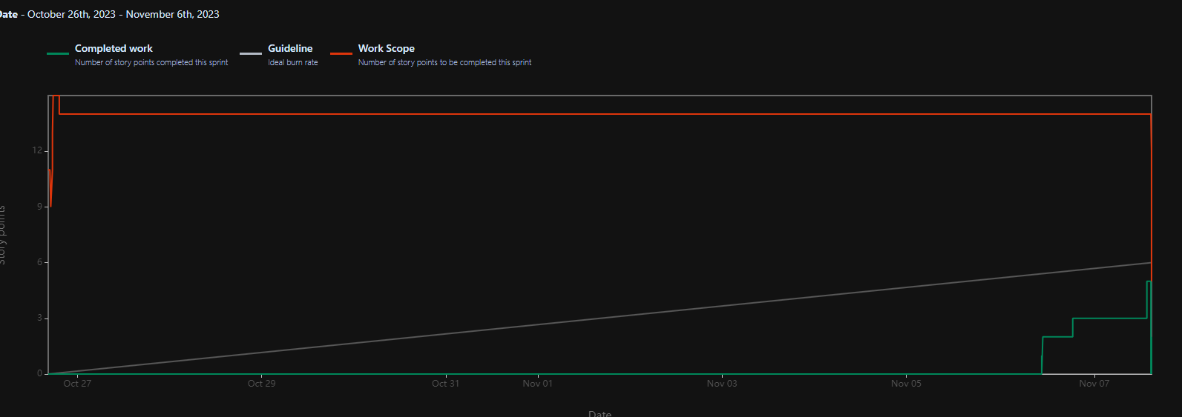

Based on the Burnup chart, we observed that we were behind schedule for the majority of the sprint. This was primarily caused by midterms and traveling for a few of our members. As a result, it wasn't until the second week, once our new backend was in place, that we could all begin our tasks

Moving forward, the team will try to identify what tasks may halt development and take the initiative to ensure it gets done in time.